> View(data)

> corolla <- data[c("Price","Age_08_04","KM","HP","cc","Doors","Gears","Quarterly_Tax","Weight")]

> View(corolla)

> summary(corolla)# 1st moment business decision

Price Age_08_04 KM HP cc

Min. : 4350 Min. : 1.00 Min. : 1 Min. : 69.0 Min. : 1300

1st Qu.: 8450 1st Qu.:44.00 1st Qu.: 43000 1st Qu.: 90.0 1st Qu.: 1400

Median : 9900 Median :61.00 Median : 63390 Median :110.0 Median : 1600

Mean :10731 Mean :55.95 Mean : 68533 Mean :101.5 Mean : 1577

3rd Qu.:11950 3rd Qu.:70.00 3rd Qu.: 87021 3rd Qu.:110.0 3rd Qu.: 1600

Max. :32500 Max. :80.00 Max. :243000 Max. :192.0 Max. :16000

Doors Gears Quarterly_Tax Weight

Min. :2.000 Min. :3.000 Min. : 19.00 Min. :1000

1st Qu.:3.000 1st Qu.:5.000 1st Qu.: 69.00 1st Qu.:1040

Median :4.000 Median :5.000 Median : 85.00 Median :1070

Mean :4.033 Mean :5.026 Mean : 87.12 Mean :1072

3rd Qu.:5.000 3rd Qu.:5.000 3rd Qu.: 85.00 3rd Qu.:1085

Max. :5.000 Max. :6.000 Max. :283.00 Max. :1615

> str(corolla)

'data.frame': 1436 obs. of 9 variables:

$ Price : int 13500 13750 13950 14950 13750 12950 16900 18600 21500 12950 ...

$ Age_08_04 : int 23 23 24 26 30 32 27 30 27 23 ...

$ KM : int 46986 72937 41711 48000 38500 61000 94612 75889 19700 71138 ...

$ HP : int 90 90 90 90 90 90 90 90 192 69 ...

$ cc : int 2000 2000 2000 2000 2000 2000 2000 2000 1800 1900 ...

$ Doors : int 3 3 3 3 3 3 3 3 3 3 ...

$ Gears : int 5 5 5 5 5 5 5 5 5 5 ...

$ Quarterly_Tax: int 210 210 210 210 210 210 210 210 100 185 ...

$ Weight : int 1165 1165 1165 1165 1170 1170 1245 1245 1185 1105 ...

> attach(corolla)

> library(psych)

> describe(corolla) #2nd 3rd &4th moment business decision

vars n mean sd median trimmed mad min max

Price 1 1436 10730.82 3626.96 9900.0 10160.59 2446.29 4350 32500

Age_08_04 2 1436 55.95 18.60 61.0 57.93 17.79 1 80

KM 3 1436 68533.26 37506.45 63389.5 65249.58 32517.12 1 243000

HP 4 1436 101.50 14.98 110.0 102.96 0.00 69 192

cc 5 1436 1576.86 424.39 1600.0 1548.26 0.00 1300 16000

Doors 6 1436 4.03 0.95 4.0 4.04 1.48 2 5

Gears 7 1436 5.03 0.19 5.0 5.00 0.00 3 6

Quarterly_Tax 8 1436 87.12 41.13 85.0 78.84 23.72 19 283

Weight 9 1436 1072.46 52.64 1070.0 1066.13 37.06 1000 1615

range skew kurtosis se

Price 28150 1.70 3.71 95.71

Age_08_04 79 -0.82 -0.08 0.49

KM 242999 1.01 1.67 989.76

HP 123 0.95 8.79 0.40

cc 14700 27.37 926.17 11.20

Doors 3 -0.08 -1.87 0.03

Gears 3 2.28 37.51 0.00

Quarterly_Tax 264 1.99 4.27 1.09

Weight 615 3.10 19.26 1.39

> plot(Price,Age_08_04)

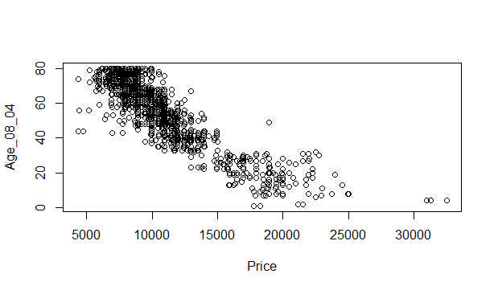

plot(Price,KM)

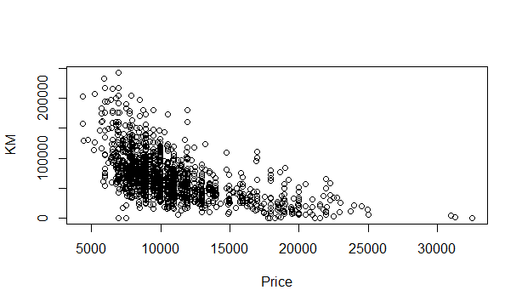

plot(Price,HP)

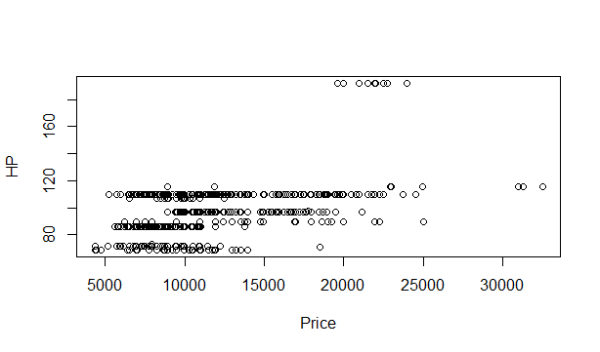

plot(Price,cc)

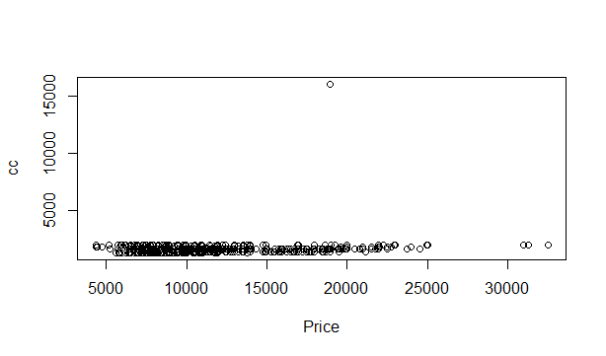

plot(Price,Doors)

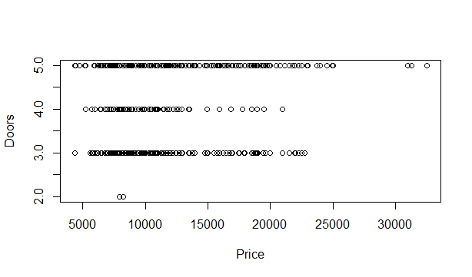

plot(Price,Gears)

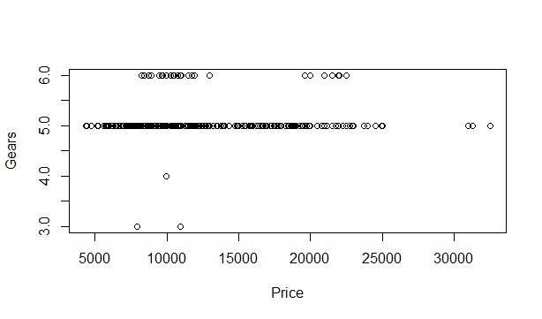

plot(Price,Quarterly_Tax)

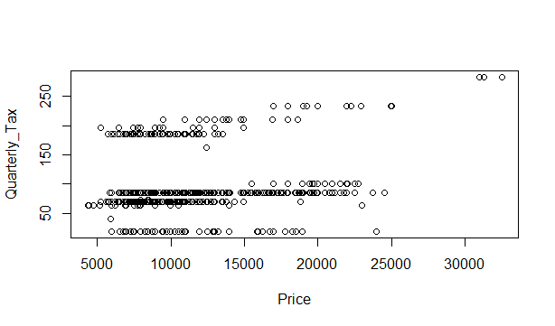

plot(Price,Weight)

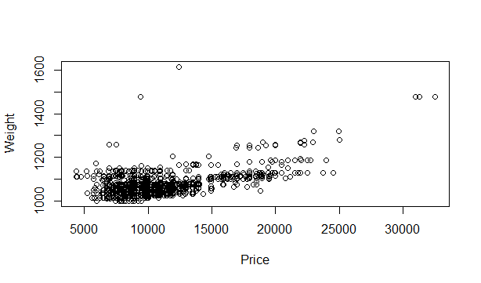

> pairs(corolla)

> cor(corolla)

Price Age_08_04 KM HP cc

Price 1.00000000 -0.876590497 -0.56996016 0.31498983 0.12638920

Age_08_04 -0.87659050 1.000000000 0.50567218 -0.15662202 -0.09808374

KM -0.56996016 0.505672180 1.00000000 -0.33353795 0.10268289

HP 0.31498983 -0.156622020 -0.33353795 1.00000000 0.03585580

cc 0.12638920 -0.098083739 0.10268289 0.03585580 1.00000000

Doors 0.18532555 -0.148359215 -0.03619661 0.09242450 0.07990330

Gears 0.06310386 -0.005363947 0.01502333 0.20947715 0.01462935

Quarterly_Tax 0.21919691 -0.198430508 0.27816470 -0.29843172 0.30699580

Weight 0.58119759 -0.470253184 -0.02859846 0.08961406 0.33563740

Doors Gears Quarterly_Tax Weight

Price 0.18532555 0.063103857 0.219196911 0.58119759

Age_08_04 -0.14835921 -0.005363947 -0.198430508 -0.47025318

KM -0.03619661 0.015023328 0.278164697 -0.02859846

HP 0.09242450 0.209477146 -0.298431717 0.08961406

cc 0.07990330 0.014629352 0.306995798 0.33563740

Doors 1.00000000 -0.160141430 0.109363225 0.30261764

Gears -0.16014143 1.000000000 -0.005451955 0.02061328

Quarterly_Tax 0.10936323 -0.005451955 1.000000000 0.62613373

Weight 0.30261764 0.020613284 0.626133733 1.00000000

> library(corpcor)

> cor2pcor(cor(corolla))

[,1] [,2] [,3] [,4] [,5] [,6]

[1,] 1.000000000 -0.776238352 -0.402745405 0.28521314 -0.03556185 -0.001069746

[2,] -0.776238352 1.000000000 0.002383081 0.24531845 -0.02014628 -0.002800916

[3,] -0.402745405 0.002383081 1.000000000 -0.06039653 0.05108725 0.026724172

[4,] 0.285213137 0.245318454 -0.060396533 1.00000000 0.09871851 0.068175272

[5,] -0.035561846 -0.020146283 0.051087249 0.09871851 1.00000000 -0.016060377

[6,] -0.001069746 -0.002800916 0.026724172 0.06817527 -0.01606038 1.000000000

[7,] 0.079586710 0.051074865 0.100506331 0.20769268 -0.01198838 -0.189249333

[8,] 0.079548117 0.015830863 0.261673195 -0.38254954 0.12380803 -0.074825415

[9,] 0.387523482 0.094746528 0.187502181 0.12427899 0.16043171 0.231960007

[,7] [,8] [,9]

[1,] 0.07958671 0.07954812 0.38752348

[2,] 0.05107486 0.01583086 0.09474653

[3,] 0.10050633 0.26167319 0.18750218

[4,] 0.20769268 -0.38254954 0.12427899

[5,] -0.01198838 0.12380803 0.16043171

[6,] -0.18924933 -0.07482541 0.23196001

[7,] 1.00000000 0.03732241 -0.02325832

[8,] 0.03732241 1.00000000 0.51026027

[9,] -0.02325832 0.51026027 1.00000000

>model1 <- lm(Price~.,data = corolla)

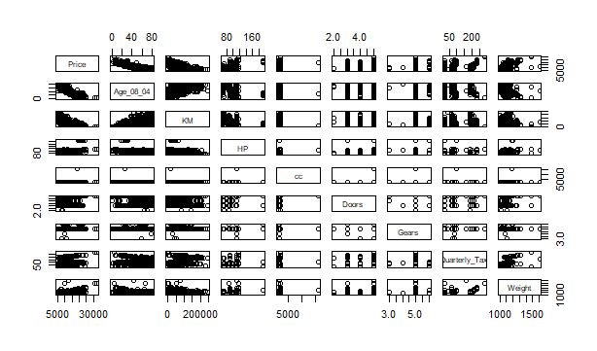

> summary(model1) #R^2=0.8638

Call:

lm(formula = Price ~ ., data = corolla)

Residuals:

Min 1Q Median 3Q Max

-9366.4 -793.3 -21.3 799.7 6444.0

Coefficients:

Estimate Std. Error t value Pr(>|t|)

(Intercept) -5.573e+03 1.411e+03 -3.949 8.24e-05 ***

Age_08_04 -1.217e+02 2.616e+00 -46.512 < 2e-16 ***

KM -2.082e-02 1.252e-03 -16.622 < 2e-16 ***

HP 3.168e+01 2.818e+00 11.241 < 2e-16 ***

cc -1.211e-01 9.009e-02 -1.344 0.17909

Doors -1.617e+00 4.001e+01 -0.040 0.96777

Gears 5.943e+02 1.971e+02 3.016 0.00261 **

Quarterly_Tax 3.949e+00 1.310e+00 3.015 0.00262 **

Weight 1.696e+01 1.068e+00 15.880 < 2e-16 ***

---

Signif. codes: 0 ‘***’ 0.001 ‘**’ 0.01 ‘*’ 0.05 ‘.’ 0.1 ‘ ’ 1

Residual standard error: 1342 on 1427 degrees of freedom

Multiple R-squared: 0.8638, Adjusted R-squared: 0.863

F-statistic: 1131 on 8 and 1427 DF, p-value: < 2.2e-16

> library(car)

Loading required package: carData

Attaching package: ‘carData’

The following object is masked _by_ ‘.GlobalEnv’:

Salaries

Attaching package: ‘car’

The following object is masked from ‘package:psych’:

logit

Warning message:

package ‘car’ was built under R version 4.0.5

> vif(model1) #no colinearity problem

Age_08_04 KM HP cc Doors Gears

1.884620 1.756905 1.419422 1.163894 1.156575 1.098723

Quarterly_Tax Weight

2.311431 2.516420

> rmse <- mean(model1$residuals^2)^.5 #1338.2584

> pred <- predict(model1,corolla)

> cor(pred,corolla$Price) #0.929

[1] 0.9293884

> influence.measures(model1)

Influence measures of

lm(formula = Price ~ ., data = corolla) :

dfb.1_ dfb.A_08 dfb.KM dfb.HP dfb.cc dfb.Dors dfb.Gers dfb.Qr_T

1 -4.12e-02 0.044717 0.059027 -1.17e-03 -0.014976 0.096060 2.24e-02 -0.15549

2 -3.45e-02 0.059102 -0.001105 -1.01e-02 -0.008099 0.074401 2.04e-02 -0.10665

3 -3.31e-02 0.028508 0.063641 1.27e-03 -0.013590 0.082311 1.84e-02 -0.13673

4 -1.60e-02 0.013970 0.028753 -4.75e-04 -0.006510 0.042743 9.91e-03 -0.06938

5 -1.52e-02 -0.002741 0.072923 5.05e-03 -0.010744 0.072989 1.52e-02 -0.11718

6 -1.58e-02 0.011740 0.039079 -2.56e-03 -0.008133 0.076683 1.86e-02 -0.11158

7 -4.33e-03 -0.001858 0.002233 -1.24e-03 -0.001166 -0.008777 -2.00e-03 0.00223

8 -4.38e-02 0.005095 -0.009213 -1.65e-02 -0.008850 -0.078473 -1.60e-02 0.02698

9 -4.82e-03 -0.007519 0.018792 1.85e-01 -0.016752 -0.072732 -6.05e-02 0.03886

10 -4.18e-02 0.056381 0.001804 4.19e-02 -0.014742 0.031078 -1.63e-03 -0.05328

11 -2.34e-02 -0.003322 0.004450 3.12e-02 -0.003189 -0.008842 2.16e-02 0.00595

12 6.08e-02 0.016464 -0.021051 -8.51e-02 0.008999 0.023878 -5.72e-02 -0.01386

13 7.98e-02 0.011624 -0.015717 -1.07e-01 0.010912 0.030160 -7.36e-02 -0.02016

14 -1.14e-01 0.002057 0.005068 1.43e-01 -0.014351 -0.040780 1.01e-01 0.03076

15 -2.24e-01 -0.003950 0.029979 2.85e-01 -0.029841 -0.080774 1.97e-01 0.05514

16 -1.16e-01 -0.002026 0.004349 1.47e-01 -0.014424 -0.042010 1.05e-01 0.03242

17 -1.44e-02 -0.021249 0.070161 4.38e-01 -0.041670 -0.170348 -1.43e-01 0.08288

18 9.83e-03 -0.035375 -0.006408 8.06e-03 -0.000768 -0.044804 -1.39e-02 -0.00758

19 7.65e-03 -0.049976 0.016069 -8.49e-03 0.012411 -0.036576 -9.43e-03 -0.05500

20 1.12e-02 -0.065751 0.045563 2.35e-02 -0.005941 -0.064418 -2.40e-02 -0.02552

21 6.62e-03 -0.039214 0.028962 1.40e-02 -0.003607 -0.036965 -1.40e-02 -0.01534

22 -8.58e-03 -0.004383 0.001515 8.53e-04 -0.004328 -0.017932 -5.07e-03 -0.00946

23 -1.92e-04 -0.013834 0.008533 3.81e-03 -0.001912 -0.016296 -5.52e-03 -0.00812

24 -1.56e-03 -0.017874 -0.000289 4.07e-03 -0.002538 -0.031518 -9.56e-03 -0.01167

25 -7.17e-04 -0.004141 -0.001673 9.24e-04 -0.000664 -0.009331 -2.74e-03 -0.00310

26 4.87e-05 0.008859 0.000228 -1.58e-03 0.000975 0.013365 4.01e-03 0.00481

27 -1.32e-03 -0.029687 0.003168 6.54e-03 -0.003868 -0.046288 -1.42e-02 -0.01788

28 -2.05e-04 -0.002483 0.000673 6.61e-04 -0.000376 -0.003946 -1.25e-03 -0.00164

29 -1.21e-03 -0.027988 0.010135 7.17e-03 -0.003911 -0.039560 -1.27e-02 -0.01718

30 -6.59e-03 -0.012143 -0.030217 1.74e-03 -0.002701 -0.055746 -1.51e-02 -0.01381

31 3.82e-02 0.034096 0.017837 7.94e-02 0.004270 0.070814 2.95e-03 0.13013

32 -8.05e-04 0.003949 -0.000468 1.48e-03 0.001129 0.003451 6.24e-04 0.00156

33 1.87e-03 -0.011999 -0.002414 -7.09e-03 -0.004836 -0.015046 -2.50e-03 -0.00596

34 -1.98e-03 0.011862 0.000633 5.98e-03 0.004320 0.013257 2.29e-03 0.00557

35 -1.69e-03 0.008503 -0.001982 2.76e-03 0.002342 0.006964 1.33e-03 0.00339

36 2.35e-03 -0.014565 0.003079 -5.57e-03 -0.004827 -0.014102 -2.70e-03 -0.00682

37 9.40e-04 -0.005066 -0.001315 -2.95e-03 -0.001876 -0.005997 -9.58e-04 -0.00225

38 -6.04e-03 0.026327 0.019627 2.01e-02 0.010083 0.035176 4.70e-03 0.01015

39 4.01e-04 -0.011017 -0.009881 -1.19e-02 -0.007492 -0.023547 -3.63e-03 -0.00825

40 -2.20e-03 0.014005 0.003877 8.78e-03 0.005787 0.018187 2.96e-03 0.00698

41 -1.14e-02 0.059259 -0.021871 1.58e-02 0.015595 0.044677 9.19e-03 0.02394

42 6.72e-03 -0.044813 0.009761 -1.76e-02 -0.015550 -0.045113 -8.68e-03 -0.02194

43 -1.15e-02 0.059488 -0.019985 1.67e-02 0.015834 0.045792 9.25e-03 0.02395

44 -6.30e-03 -0.003720 0.005154 -6.01e-04 -0.002857 0.000786 -8.74e-04 0.00828

45 8.43e-03 0.007321 -0.006244 1.47e-03 0.004023 -0.001281 1.12e-03 -0.01314

46 -2.68e-02 -0.004289 0.000106 -8.38e-03 -0.009548 0.000740 -1.59e-03 0.02643

47 -1.42e-02 0.000349 -0.004099 -4.22e-03 -0.004893 0.002078 -7.09e-04 0.02099

48 1.46e-03 -0.025633 0.017528 -6.29e-03 -0.006462 0.008986 8.55e-04 -0.01131

49 1.42e-03 0.000314 0.000542 5.31e-04 0.000518 -0.000244 6.07e-05 -0.00243

50 -2.18e-01 -0.032934 0.083345 2.64e-01 -0.032425 0.038219 2.01e-01 0.03610

51 5.23e-03 0.000112 0.003809 2.28e-03 0.001731 -0.000934 7.85e-05 -0.00920

52 -3.02e-03 -0.028618 0.012486 -1.55e-02 -0.011643 0.017847 2.95e-03 -0.01734

53 -8.15e-02 -0.060152 0.046908 -4.03e-03 -0.037384 0.018114 -1.14e-02 -0.08500

54 -1.82e-02 -0.034702 0.077997 3.00e-01 -0.031489 -0.015175 -8.18e-02 0.05001

55 1.94e-02 0.022882 -0.011226 -5.13e-04 0.010373 -0.009138 3.34e-03 0.02066

56 -1.61e-02 0.030300 -0.006484 -1.11e-02 -0.001991 -0.022955 1.56e-03 -0.00650

57 -2.31e-04 -0.002337 0.000299 -1.58e-03 -0.000975 0.001637 3.35e-04 -0.00134

58 1.75e-04 0.003736 -0.000635 2.24e-03 0.001380 -0.002327 -4.70e-04 0.00192

59 -3.11e-02 -0.021118 0.005222 -4.72e-03 -0.013535 0.007665 -3.37e-03 -0.02992

60 -2.23e-03 -0.004192 0.000355 2.86e-05 -0.000866 0.003301 -3.69e-04 -0.00352

61 -7.02e-04 0.030835 -0.003819 1.68e-02 0.009595 -0.016899 -3.60e-03 0.01330

62 -2.45e-03 -0.007079 0.000916 1.08e-05 -0.001121 0.004483 -4.93e-04 -0.00478

63 -2.68e-02 -0.039307 -0.003720 -9.01e-04 -0.009325 0.036919 -3.64e-03 -0.03759

64 -1.75e-02 -0.027441 -0.005331 -1.39e-03 -0.006001 0.025297 -2.20e-03 -0.02473

65 -5.49e-03 -0.050207 -0.008726 -4.17e-02 -0.022202 0.040012 9.35e-03 -0.02797

66 -1.72e-03 -0.060191 0.023555 -1.81e-02 0.015055 0.029840 2.37e-03 -0.07346

67 -2.06e-02 -0.042119 -0.007579 -2.51e-03 -0.007553 0.033863 -2.70e-03 -0.03234

68 -3.96e-04 0.031936 0.001485 2.02e-02 0.010512 -0.019421 -4.54e-03 0.01369

69 -5.65e-02 0.036023 -0.073514 3.72e-02 -0.022532 -0.002838 -1.50e-02 0.10463

70 -2.04e-04 -0.003457 -0.000642 -2.69e-03 -0.001379 0.002547 6.11e-04 -0.00172

71 -1.50e-03 -0.008950 -0.003496 -8.91e-03 -0.004514 0.008324 2.05e-03 -0.00541

dfb.Wght dffit cov.r cook.d hat inf

1 0.023320 -0.25567 0.978 7.24e-03 0.01047 *

2 0.019444 -0.18914 0.994 3.97e-03 0.00992

3 0.018183 -0.22205 0.988 5.46e-03 0.01068

4 0.008110 -0.11251 1.009 1.41e-03 0.01025

5 0.000423 -0.19281 0.995 4.12e-03 0.01071

6 -0.000719 -0.18731 0.993 3.89e-03 0.00944

7 0.008727 0.01779 1.019 3.52e-05 0.01276 *

8 0.082656 0.15942 1.006 2.82e-03 0.01257

9 0.020912 0.21168 1.036 4.98e-03 0.03591 *

10 0.036831 -0.12339 1.008 1.69e-03 0.01062

11 0.003699 0.04817 1.050 2.58e-04 0.04190 *

12 -0.008326 -0.13015 1.049 1.88e-03 0.04273 *

13 -0.012592 -0.16428 1.046 3.00e-03 0.04193 *

14 0.022039 0.22291 1.042 5.52e-03 0.04157 *

15 0.043955 0.43900 1.021 2.14e-02 0.04177 *

16 0.020591 0.23016 1.042 5.88e-03 0.04154 *

17 0.052794 0.49632 1.002 2.73e-02 0.03641 *

18 0.011037 0.07777 1.002 6.72e-04 0.00443

19 0.015975 0.08981 1.007 8.96e-04 0.00751

20 0.019755 0.10940 0.994 1.33e-03 0.00449

21 0.011202 0.06388 1.006 4.54e-04 0.00468

22 0.019490 0.02920 1.012 9.48e-05 0.00684

23 0.008844 0.02681 1.010 7.99e-05 0.00483

24 0.018014 0.04995 1.007 2.77e-04 0.00435

25 0.005563 0.01479 1.010 2.43e-05 0.00431

26 -0.007030 -0.02195 1.010 5.36e-05 0.00465

27 0.025555 0.07410 1.003 6.10e-04 0.00445

28 0.002277 0.00619 1.011 4.26e-06 0.00431

29 0.022042 0.06302 1.005 4.41e-04 0.00446

30 0.035204 0.09287 0.999 9.58e-04 0.00466

31 -0.100056 -0.17749 0.997 3.50e-03 0.01010

32 -0.001246 -0.00678 1.011 5.12e-06 0.00501

33 0.006998 0.02766 1.010 8.50e-05 0.00433

34 -0.005854 -0.02457 1.010 6.71e-05 0.00443

35 -0.002466 -0.01374 1.011 2.10e-05 0.00509

36 0.006038 0.02611 1.010 7.58e-05 0.00449

37 0.002592 0.01142 1.011 1.45e-05 0.00462

38 -0.014521 -0.07204 1.005 5.77e-04 0.00522

39 0.013373 0.04161 1.008 1.92e-04 0.00397

40 -0.008507 -0.03358 1.009 1.25e-04 0.00436

41 -0.015377 -0.08941 1.002 8.88e-04 0.00530

42 0.020118 0.08227 1.001 7.52e-04 0.00436

43 -0.015877 -0.09121 1.002 9.24e-04 0.00523

44 0.008379 0.02692 1.018 8.06e-05 0.01197

45 -0.011509 -0.04065 1.018 1.84e-04 0.01195

46 0.036154 0.09173 1.015 9.35e-04 0.01255

47 0.018015 0.05522 1.016 3.39e-04 0.01160

48 0.002018 0.03364 1.011 1.26e-04 0.00589

49 -0.001849 -0.00628 1.018 4.39e-06 0.01176

50 0.023334 0.41197 1.026 1.88e-02 0.04256 *

51 -0.006719 -0.02282 1.018 5.79e-05 0.01201

52 0.009119 0.05043 1.005 2.83e-04 0.00354

53 0.128377 0.20708 0.963 4.74e-03 0.00544 *

54 0.019377 0.33250 1.020 1.23e-02 0.03345 *

55 -0.031619 -0.06294 1.005 4.40e-04 0.00440

56 0.021276 -0.04811 1.005 2.57e-04 0.00312

57 0.000753 0.00455 1.010 2.30e-06 0.00355

58 -0.000922 -0.00670 1.010 4.99e-06 0.00380

59 0.049226 0.08144 1.004 7.37e-04 0.00535

60 0.003732 0.01138 1.009 1.44e-05 0.00298

61 -0.004637 -0.05153 1.007 2.95e-04 0.00432

62 0.004491 0.01607 1.009 2.87e-05 0.00324

63 0.043350 0.12513 0.976 1.73e-03 0.00291 *

64 0.028632 0.08650 0.994 8.30e-04 0.00299

65 0.017563 0.11166 0.989 1.38e-03 0.00367

66 0.012862 0.11079 1.002 1.36e-03 0.00676

67 0.035459 0.11845 0.982 1.56e-03 0.00315

68 -0.005499 -0.05856 1.006 3.81e-04 0.00430

69 0.068499 0.22238 1.002 5.49e-03 0.01534

70 0.000965 0.00732 1.010 5.96e-06 0.00392

71 0.003947 0.02295 1.009 5.86e-05 0.00362

[ reached 'max' / getOption("max.print") -- omitted 1365 rows ]

> influenceIndexPlot(model1,id=list(col="red",cex=2,n=10))

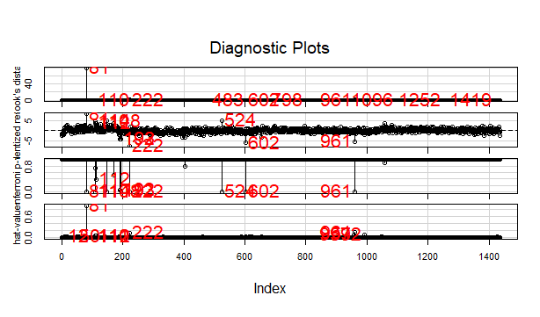

> influencePlot(model1,id=list(col='red',cex=2,n=10))

StudRes Hat CookD

12 -0.6160047 0.042730745 0.001882872

50 1.9539709 0.042560241 0.018820428

81 8.1645001 0.918236817 79.520106241

110 4.5804418 0.051530771 0.124904169

111 3.4776622 0.051056873 0.071743570

112 3.6509430 0.051349872 0.079481248

148 4.7530461 0.005021885 0.012480526

192 -4.1091012 0.017931350 0.033877757

193 -4.2258247 0.014239567 0.028327317

222 -7.6732619 0.139711645 1.021031219

524 4.8579994 0.008225564 0.021409224

602 -6.1797985 0.036238109 0.155499309

655 -3.3381277 0.035984596 0.045890205

957 0.3969907 0.089268058 0.001717434

961 -5.4561946 0.157248409 0.604999566

992 -2.1685686 0.092688709 0.053241331

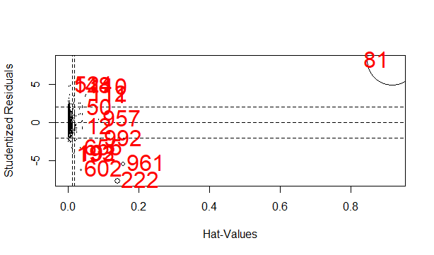

>qqplot(model1)

[1] 81 222

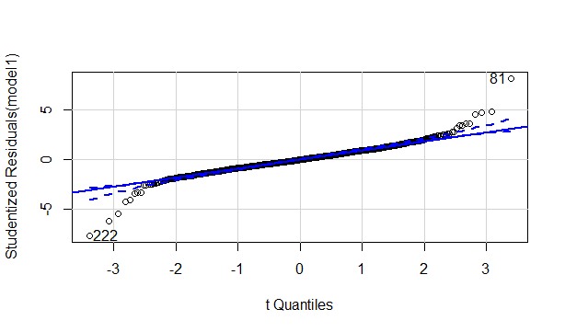

> residualPlot(model1)

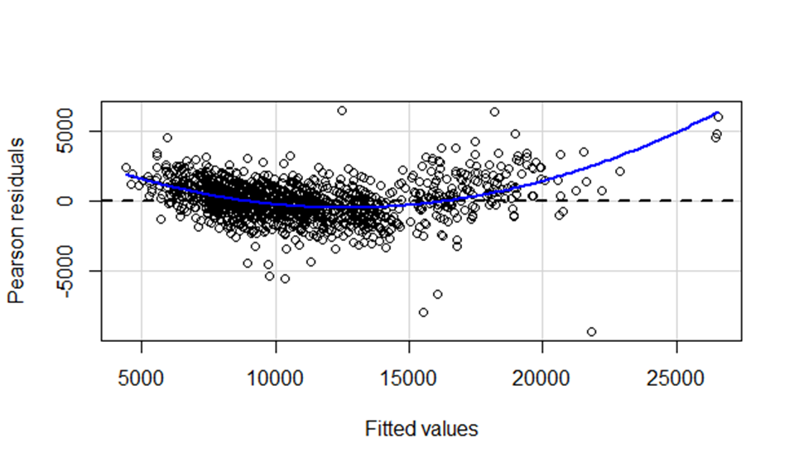

> modelcc <- lm(Price~cc,data = corolla)

> summary(modelcc)

Call:

lm(formula = Price ~ cc, data = corolla)

Residuals:

Min 1Q Median 3Q Max

-7360.2 -2305.8 -855.8 1194.2 21312.1

Coefficients:

Estimate Std. Error t value Pr(>|t|)

(Intercept) 9027.5548 365.5755 24.694 < 2e-16 ***

cc 1.0802 0.2239 4.825 1.55e-06 ***

---

Signif. codes: 0 ‘***’ 0.001 ‘**’ 0.01 ‘*’ 0.05 ‘.’ 0.1 ‘ ’ 1

Residual standard error: 3599 on 1434 degrees of freedom

Multiple R-squared: 0.01597, Adjusted R-squared: 0.01529

F-statistic: 23.28 on 1 and 1434 DF, p-value: 1.551e-06

> modeldoors <- lm(Price~Doors,data = corolla)

> summary(modeldoors)

Call:

lm(formula = Price ~ Doors, data = corolla)

Residuals:

Min 1Q Median 3Q Max

-7062.8 -2251.7 -915.3 958.0 21087.2

Coefficients:

Estimate Std. Error t value Pr(>|t|)

(Intercept) 7885.01 409.44 19.258 < 2e-16 ***

Doors 705.56 98.79 7.142 1.46e-12 ***

---

Signif. codes: 0 ‘***’ 0.001 ‘**’ 0.01 ‘*’ 0.05 ‘.’ 0.1 ‘ ’ 1

Residual standard error: 3565 on 1434 degrees of freedom

Multiple R-squared: 0.03435, Adjusted R-squared: 0.03367

F-statistic: 51 on 1 and 1434 DF, p-value: 1.461e-12

> modelccdoors <- lm(Price~cc+Doors,data = corolla)

> summary(modelccdoors)

Call:

lm(formula = Price ~ cc + Doors, data = corolla)

Residuals:

Min 1Q Median 3Q Max

-7243.9 -2273.6 -821.3 1054.4 20714.1

Coefficients:

Estimate Std. Error t value Pr(>|t|)

(Intercept) 6509.4211 515.7732 12.621 < 2e-16 ***

cc 0.9597 0.2211 4.340 1.52e-05 ***

Doors 671.3973 98.5009 6.816 1.37e-11 ***

---

Signif. codes: 0 ‘***’ 0.001 ‘**’ 0.01 ‘*’ 0.05 ‘.’ 0.1 ‘ ’ 1

Residual standard error: 3543 on 1433 degrees of freedom

Multiple R-squared: 0.04688, Adjusted R-squared: 0.04555

F-statistic: 35.24 on 2 and 1433 DF, p-value: 1.15e-15

> #deleting the influenced observations

> model2 <- lm(Price~.,data = corolla[-c(81,222),])

> summary(model2) #R^2=0.8778 #doors are not influencing factors

Call:

lm(formula = Price ~ ., data = corolla[-c(81, 222), ])

Residuals:

Min 1Q Median 3Q Max

-10451.2 -754.1 -22.2 743.2 6517.8

Coefficients:

Estimate Std. Error t value Pr(>|t|)

(Intercept) -1.025e+04 1.396e+03 -7.346 3.44e-13 ***

Age_08_04 -1.166e+02 2.508e+00 -46.475 < 2e-16 ***

KM -1.728e-02 1.237e-03 -13.966 < 2e-16 ***

HP 3.929e+01 2.816e+00 13.953 < 2e-16 ***

cc -3.206e+00 3.050e-01 -10.511 < 2e-16 ***

Doors -6.537e+01 3.815e+01 -1.713 0.08685 .

Gears 4.850e+02 1.866e+02 2.599 0.00944 **

Quarterly_Tax 7.966e+00 1.382e+00 5.762 1.01e-08 ***

Weight 2.505e+01 1.186e+00 21.129 < 2e-16 ***

---

Signif. codes: 0 ‘***’ 0.001 ‘**’ 0.01 ‘*’ 0.05 ‘.’ 0.1 ‘ ’ 1

Residual standard error: 1270 on 1425 degrees of freedom

Multiple R-squared: 0.8778, Adjusted R-squared: 0.8772

F-statistic: 1280 on 8 and 1425 DF, p-value: < 2.2e-16

> rmse2 <- mean(model2$residuals^2)^.5 #1265

> pred2 <- predict(model2,corolla)

> cor(pred2,corolla$Price) #87.3

[1] 0.8736161

> avPlots(model2)

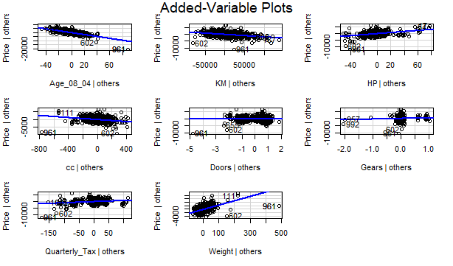

>residualplot(model2)

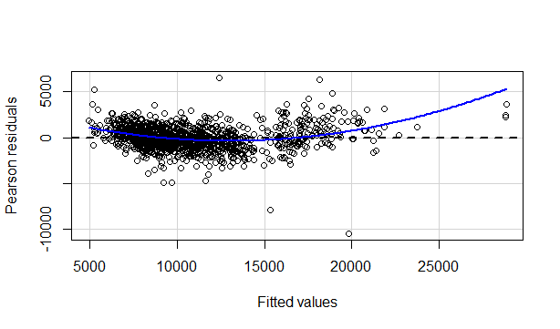

> l=log(corolla[,-1])

> corolla2 <- data.frame(l,corolla$Price)

> #log model

> model3 <- lm(corolla.Price~.,data = corolla2)

> summary(model3) #0.8353

Call:

lm(formula = corolla.Price ~ ., data = corolla2)

Residuals:

Min 1Q Median 3Q Max

-12569.4 -815.2 -17.2 832.8 9057.3

Coefficients:

Estimate Std. Error t value Pr(>|t|)

(Intercept) -106431.13 8499.15 -12.523 < 2e-16 ***

Age_08_04 -5418.00 116.54 -46.492 < 2e-16 ***

KM 146.40 49.64 2.949 0.00324 **

HP 4941.78 287.94 17.163 < 2e-16 ***

cc -2940.17 401.02 -7.332 3.79e-13 ***

Doors -226.93 172.58 -1.315 0.18874

Gears 2936.26 1086.04 2.704 0.00694 **

Quarterly_Tax 519.27 109.62 4.737 2.39e-06 ***

Weight 18491.44 1374.48 13.453 < 2e-16 ***

---

Signif. codes: 0 ‘***’ 0.001 ‘**’ 0.01 ‘*’ 0.05 ‘.’ 0.1 ‘ ’ 1

Residual standard error: 1476 on 1427 degrees of freedom

Multiple R-squared: 0.8353, Adjusted R-squared: 0.8344

F-statistic: 904.5 on 8 and 1427 DF, p-value: < 2.2e-16

> rmse3 <- mean(model3$residuals^2)^.5 #1471

> pred3 <- predict(model3,corolla2)

> cor(pred3,corolla2$corolla.Price) #91.3%

[1] 0.9139346

> avPlots(model3)

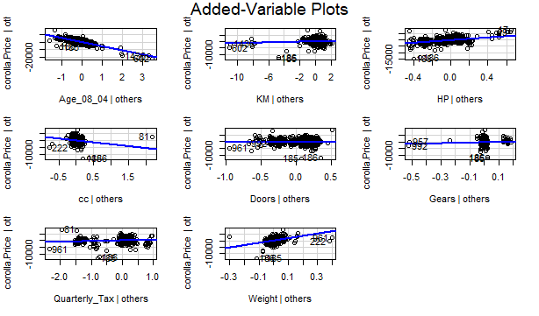

> influenceIndexPlot(model3,id=list(col='red',n=10,cex=1.5))

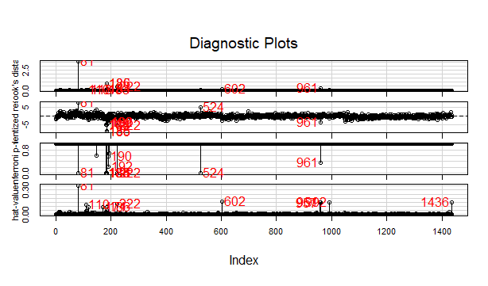

> influencePlot(model3,id=list(col='red',n=10,cex=1.5))

StudRes Hat CookD

81 7.79385939 0.354294498 3.554514e+00

110 2.18604246 0.120081622 7.227038e-02

118 -2.15112318 0.089091721 5.015892e-02

171 0.05873621 0.091558955 3.866134e-05

183 -4.95698749 0.037344801 1.041927e-01

184 -4.83816406 0.049605353 1.336524e-01

185 -9.17198938 0.087946345 8.517124e-01

186 -8.63420955 0.095342556 8.301927e-01

190 -3.54750669 0.008314449 1.162926e-02

192 -3.79292559 0.012147737 1.947397e-02

222 -5.42242992 0.128718504 4.732261e-01

524 5.34856866 0.014966238 4.737753e-02

602 -2.52385443 0.160767378 1.350736e-01

957 1.10497550 0.145772047 2.314707e-02

961 -3.67423638 0.147551724 2.573832e-01

992 -1.16135342 0.149504834 2.633683e-02

1436 -0.22907159 0.149457776 1.025206e-03

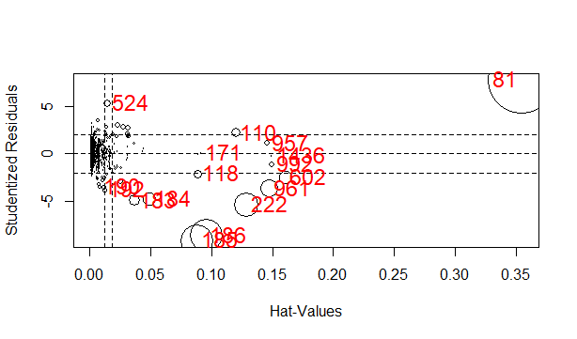

> qqPlot(model3)

[1] 185 186

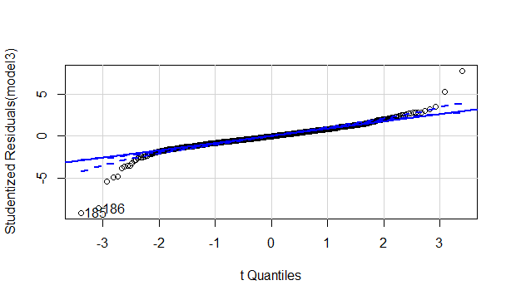

>residualplot(model3)

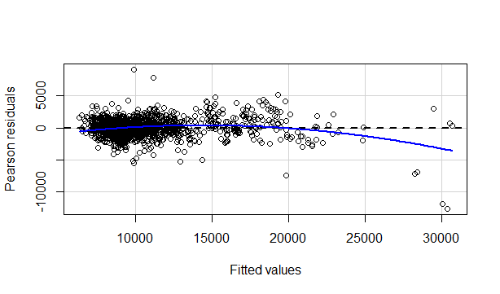

> vif(model3)

Age_08_04 KM HP cc Doors Gears

2.342217 1.859423 1.199569 1.858043 1.166956 1.066731

Quarterly_Tax Weight

1.589725 2.649495

> model4 <- lm(corolla.Price~.,data = corolla2[-c(185,186)])

> summary(model4) #0.8353

Call:

lm(formula = corolla.Price ~ ., data = corolla2[-c(185, 186)])

Residuals:

Min 1Q Median 3Q Max

-12569.4 -815.2 -17.2 832.8 9057.3

Coefficients:

Estimate Std. Error t value Pr(>|t|)

(Intercept) -106431.13 8499.15 -12.523 < 2e-16 ***

Age_08_04 -5418.00 116.54 -46.492 < 2e-16 ***

KM 146.40 49.64 2.949 0.00324 **

HP 4941.78 287.94 17.163 < 2e-16 ***

cc -2940.17 401.02 -7.332 3.79e-13 ***

Doors -226.93 172.58 -1.315 0.18874

Gears 2936.26 1086.04 2.704 0.00694 **

Quarterly_Tax 519.27 109.62 4.737 2.39e-06 ***

Weight 18491.44 1374.48 13.453 < 2e-16 ***

---

Signif. codes: 0 ‘***’ 0.001 ‘**’ 0.01 ‘*’ 0.05 ‘.’ 0.1 ‘ ’ 1

Residual standard error: 1476 on 1427 degrees of freedom

Multiple R-squared: 0.8353, Adjusted R-squared: 0.8344

F-statistic: 904.5 on 8 and 1427 DF, p-value: < 2.2e-16

> rmse4 <- mean(model4$residuals^2)^.5 #1471

> pred4 <- predict(model4,corolla2)

> cor(pred4,corolla2$corolla.Price) #91.3%

[1] 0.9139346

>plot(model2)

